Teacher Documents
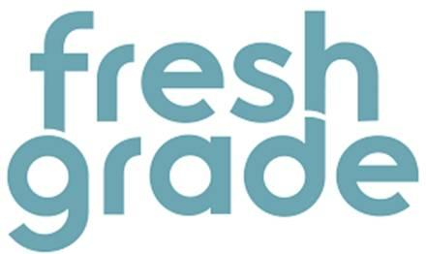
Overview of Tool: This product allows us to capture evidence of learning in the classroom. Very shortly, with your consent, you will have the opportunity to begin receiving ongoing information regarding your child’s learning via an online portfolio. This information may take the form of informal notes, pictures, or links to video or audio. You will receive these updates via email, or through the product’s app, if you so choose.
Privacy Points for Teachers
(Adapted from the Privacy and Terms: https://www.freshgrade.com/privacy-and-terms/)
- Data is stored in Canada.
- FreshGrade will not share information with a 3rd party unless students elect to use additional tools (A seperate privacy waiver will be created and sent home for those) or due to legal obligation or court order
- User data is anomyized and analyzed in aggregate to better improve the service and analyze the way in which students and teachers use the service
- Only students, parents, and teachers can view the data
- FreshGrade allows students/parents to own their own data.

