Teacher Documents
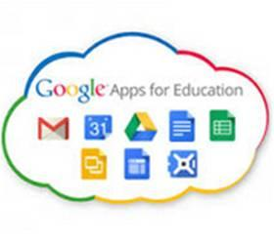
Overview of Tool: GAFE is a free, “walled garden” style learning platform where students can have discussions, share their learning and collaborate on projects. They will also gain access to a document and media creation platform similar to Microsoft Office that includes online cloud storage via through Google Drive. This private online learning environment is teacher managed and students will only be able to interact with others in the class, other teachers, and specific outside agencies based on educational need (Distance Education providers, etc).
Privacy Points for Teachers
(Adapted from the Privacy Policy: https://www.google.com/intl/en/policies/privacy/ and Terms of Use / Service: https://www.google.com/intl/en/policies/terms/)
- This account will be stored in multiple servers outside of Canada.
- For legal purposes, this account will be governed by the laws applicable to Santa Clara, California
- Google Education accounts are not subject to advertising or “ad-scanning”, making them more private than standard google accounts.
- Third party and non-education related apps are turned off and controlled to provide additional privacy protection
- Google will not share personal information with anyone unless compelled by legal requirements or court order.
- Student may register with a pseudonym and no additional information and still use the platform to its full potential

